PULSELESS ARREST IN CHILDREN
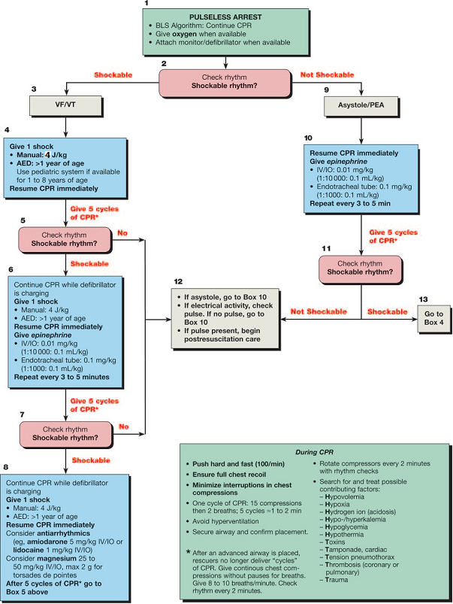

BRADYCARDIA WITH PULSE

TACHYCARDIA WITH PULSE

